|  |
| --- |
| Close up of a black dog's face looking up at the camera |
| Pet Volunteer OpportunityThis Animal Shelter is always looking for friendly volunteers that love animals and want to do what they can to help. |
| PAW PETROL |

|  |
| --- |
| Tiny brown dog  jumping in a field of grass |
| **Artificial Intelligence for Business Decisions and Transformation CSCN8030** Group:  ASSIGNMENT: 1  Prashansa Rathod - 8993410  Harsh Joshi – 8952840  Jaiv Burman - 8930180  Nidhi Ahir – 9041129  Nil Kumar Patel - 8983991 |
|  |

**PART:1 Animal Shelter Analytics Stakeholder Perspectives**

**Overview**

This project leverages data analytics to optimize animal shelter operations, focusing on improving animal welfare, increasing adoption rates, and streamlining shelter processes. The stakeholder perspectives, goals, concerns, and success metrics for this initiative are summarized below.

**Stakeholder Perspectives**

1. **Shelter Managers**

* **Goals**: Maximize animal care efficiency, reduce overcrowding, and improve adoption processes.
* **Concerns**: Limited resources, data accuracy, and resistance to technology adoption.
* **Success Metrics**: Reduced animal stay duration, improved health outcomes, and higher adoption rates.

1. **Veterinarians**

* **Goals**: Enhance animal health monitoring and treatment.
* **Concerns**: Access to real-time health data and integration with existing medical systems.
* **Success Metrics**: Faster diagnosis and treatment times, reduced illness rates, and improved vaccination coverage.

1. **Adopters and Public**

* **Goals**: Simplify the adoption process and access detailed animal profiles.
* **Concerns**: Transparency in animal health history and ease of access to shelter information.
* **Success Metrics**: Increased adoption satisfaction, higher repeat adoptions, and positive public feedback.

1. **Donors and Sponsors**

* **Goals**: Ensure resources are used effectively and demonstrate the impact of their contributions.
* **Concerns**: Accountability and visibility of project outcomes.
* **Success Metrics**: Clear reporting of project KPIs and increased donor retention rates.

1. **Data Analysts and Developers**

* **Goals**: Develop accurate and actionable predictive models for shelter operations.
* **Concerns**: Data quality, model interpretability, and collaboration with stakeholders.
* **Success Metrics**: High model accuracy, seamless integration with shelter operations, and stakeholder satisfaction with insights.

**Integration of Views**

By aligning stakeholder goals, addressing concerns, and defining clear success metrics, this project aims to create a unified decision-support system (DSS). This will improve animal welfare outcomes, streamline operations, and enhance community engagement. Each stakeholder’s input is vital to achieving a holistic solution that benefits all parties involved.

**PART:2 Data Analysis and Visualization**

**Insights from Data Analysis**

* The dataset provides detailed records of animal intakes and outcomes from Austin Animal Center.
* Key outcome types include **Adoption**, **Transfer**, **Return to Owner**, **Euthanasia**, and more.
* **Adoption** is the most frequent outcome, highlighting its importance in shelter operations.

The dataset we have contains information about animal shelter operations, focusing on the following key metrics:

* **Animal Types**: Includes categories such as dogs, cats, rabbits, and other animals.
* **Intake**: The number of animals taken in by the shelter.
* **Adopted**: The number of animals successfully adopted.
* **Euthanized**: The number of animals euthanized.
* **Calculated Metrics**: Adoption and euthanization rates have been computed for a deeper understanding of shelter performance.

**Key Insights:**

* Dogs and cats have higher adoption rates compared to other animals.
* Euthanization rates are relatively low across all categories, indicating a focus on animal welfare.

This is the dataset Of Intake table taken by the animals

Here Is the table of overall outcome of animals

**Proposed DSS-Based Solutions**

1. **Outcome Prediction System**:

* **Objective**: Forecast the likely outcomes (adoption, transfer, etc.) for incoming animals.
* **Implementation**: Use machine learning models to analyze historical data and predict outcomes based on attributes such as age, breed, and health condition.

1. **Adoption Priority Dashboard**:

* **Objective**: Identify animals with lower adoption probabilities and prioritize their visibility to adopters.
* **Implementation**: Create a dashboard highlighting animals at higher risk of prolonged stays or euthanasia.

1. **Seasonal Intake and Outcome Analysis**:

* **Objective**: Prepare shelters for seasonal trends in intakes and outcomes.
* **Implementation**: Use time-series analysis to predict seasonal variations and align resources accordingly.

1. **Enhanced Animal Profile System**:

* **Objective**: Increase adoption rates by providing detailed and visually appealing animal profiles.
* **Implementation**: Use AI-powered tools to generate descriptive profiles, including photos and behavior summaries.

1. **Resource Allocation Tool**:

* **Objective**: Optimize shelter resources (e.g., food, space) based on predicted intake trends.
* **Implementation**: Integrate predictive analytics into resource planning modules.

These data-driven solutions aim to improve animal welfare, streamline shelter operations, and maximize adoption rates. Let me know if you'd like to refine any of these or explore additional insights!

**PART:3** **Building a Simple AI Model**

**For this part We have Used Jupyter notebook the link is below**

<https://prashansarathod.github.io/CSCN8030AI/paw.html>

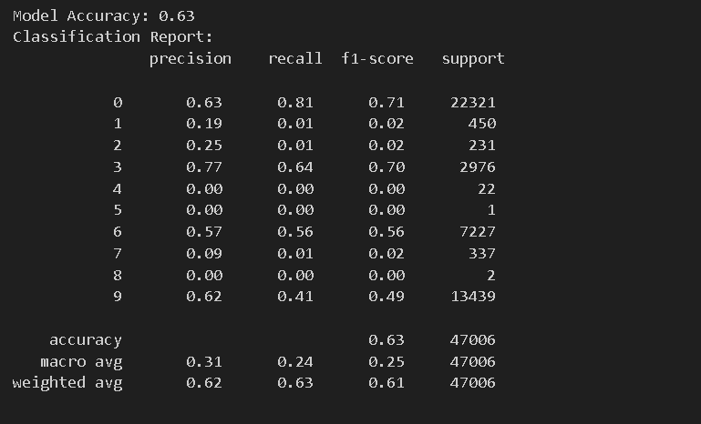

**PART:4 DSS Implementation Strategy**

**Technical Considerations**

To implement the Decision Support System (DSS) effectively:

* **Required Tools**: Python-based frameworks (e.g., Scikit-learn, Pandas) for model development and data preprocessing. Use cloud services like AWS or Azure for scalability and storage.
* **Data Pipeline**: Establish ETL (Extract, Transform, Load) processes to clean, integrate, and standardize data from multiple sources (e.g., intake and outcome datasets). Automate data updates to ensure real-time insights.
* **Model Integration**: Use RESTful APIs to embed the AI model into existing shelter management software, enabling seamless access to predictions.

**Operational Considerations**

* **Deployment**: Deploy the DSS on a cloud-based platform for ease of access across multiple shelter locations.
* **Training for Users**: Conduct training sessions for shelter staff on using the DSS interface, interpreting predictions, and leveraging insights for decision-making.
* **Scalability**: Design the system to handle increased data volumes and additional features, such as advanced predictive analytics and multi-shelter integration.

**Financial Considerations**

* **Cost of Implementation**: Estimated cost of $15,000–$20,000 for initial development, cloud deployment, and staff training.
* **Potential Savings/Benefits**: Improved resource allocation could reduce shelter operation costs by 20%. Higher adoption rates would result in cost savings on animal care and increased donor satisfaction, boosting funding opportunities.

This strategy ensures a technically sound, operationally effective, and financially sustainable DSS for improving animal shelter operations.

**Reference:**

<https://www.kaggle.com/datasets/thedevastator/austin-animal-center-data>